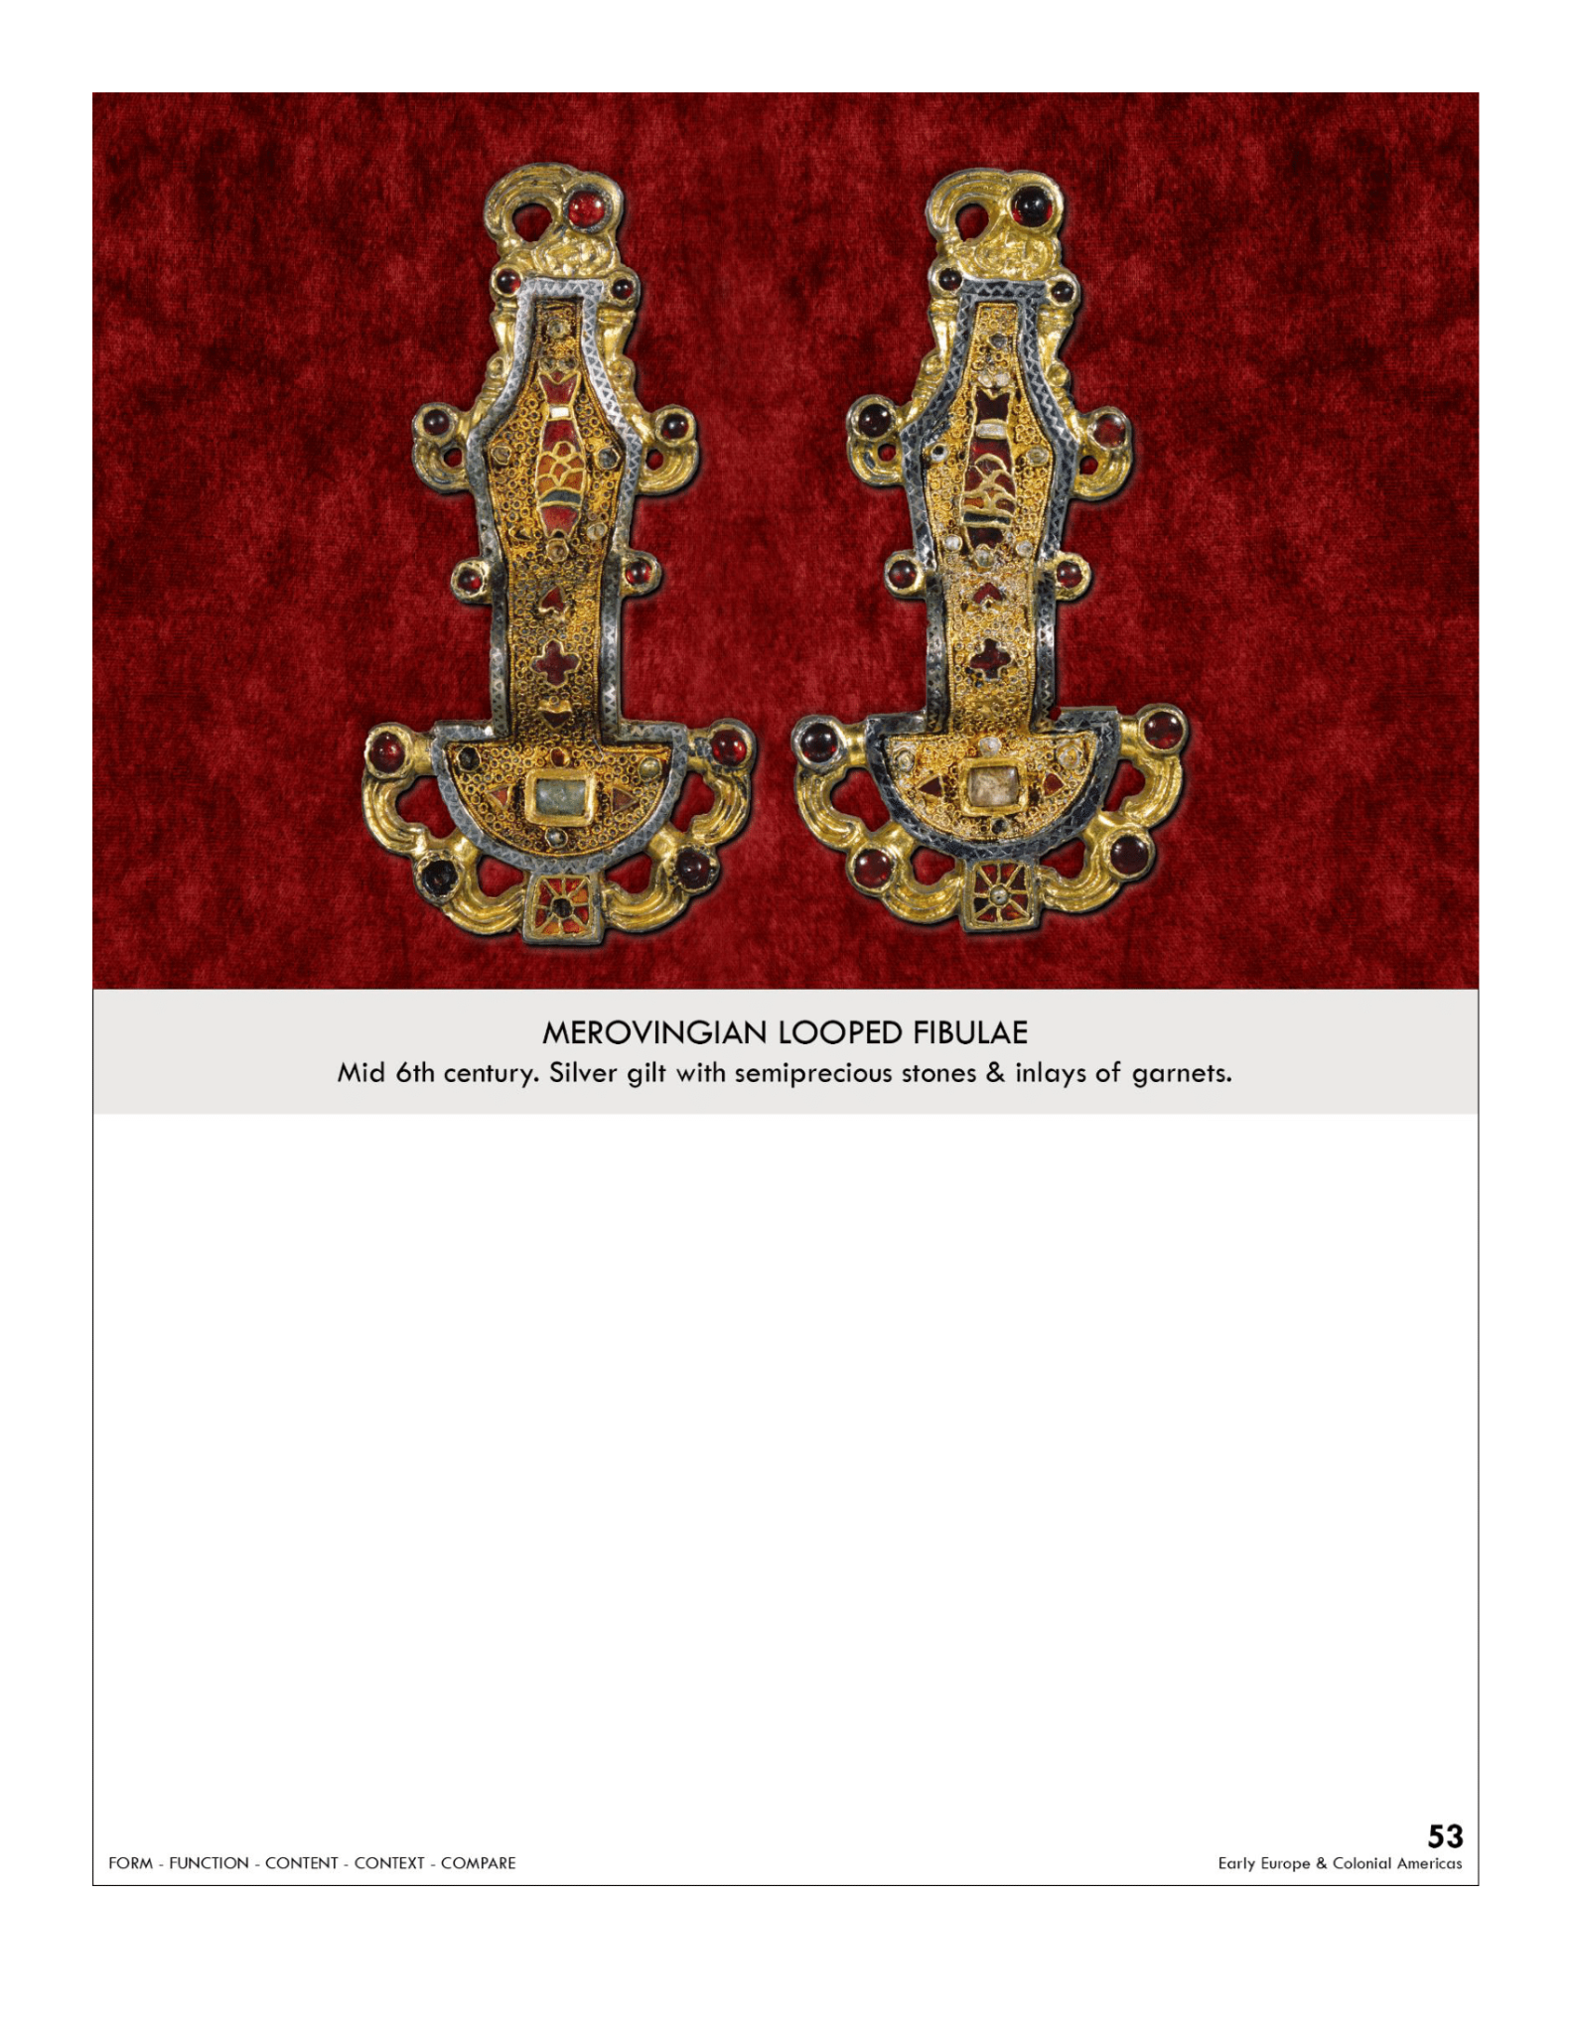

| **Form:** Jewelry, clasps for a garment/ cloak/cape or shawl, hook on each side of the clasp. Made of gold and inlays of precious jewels, **techniques**: cloisonné: technique is inlaid semi-precious stones- such as garnets (popular in barbarian art)- silver gilt worked in filigree,  -Ends of fibulae: the shape of Eagle heads**,**  and chasing techniques, inlays of stone on gold. consist of a body, a pin, and a catch, elaborate designs  **Function:** Jewelry. Decoration for a person, for fastening clothes, buried with the dead- followed in the afterlife . Owned by rich people ( wealthy Merovingian women)  **Content:** Horror vacuole of abstract design, fish in the middle. Bird at the top. Nature is providing the inspiration. the main body of the brooch: little fish . covered in decorative patterns adjusted to the objects shape. Zoomorphic elements highly disciplined, abstract design  **Context:** People lived in small camps and did not have much, Early dark ages, warrior kings, from France - predating the french kings. Mid 6th century  Fibulae: are brooches (safety pins) that were made popular by Roman military campaigns- and etruscans before them  Cultural exchanges occurred after antiquity and both groups (barbarians and Romans) copied and shared similar works  Barbarian: non-Roman, nomadic, and illiterate groups traveling throughout Europe during the middle ages  Became very popular in the early Middle Ages and commonly found in barbarian grave sites  Found through many different ethnics groups and with trade/ expose had influences of the styles of one another  In the great early Anglo- Saxon( 410-768) epic Beowulf  **Compare:**  **53**  Early Europe & Colonial America |
| --- |

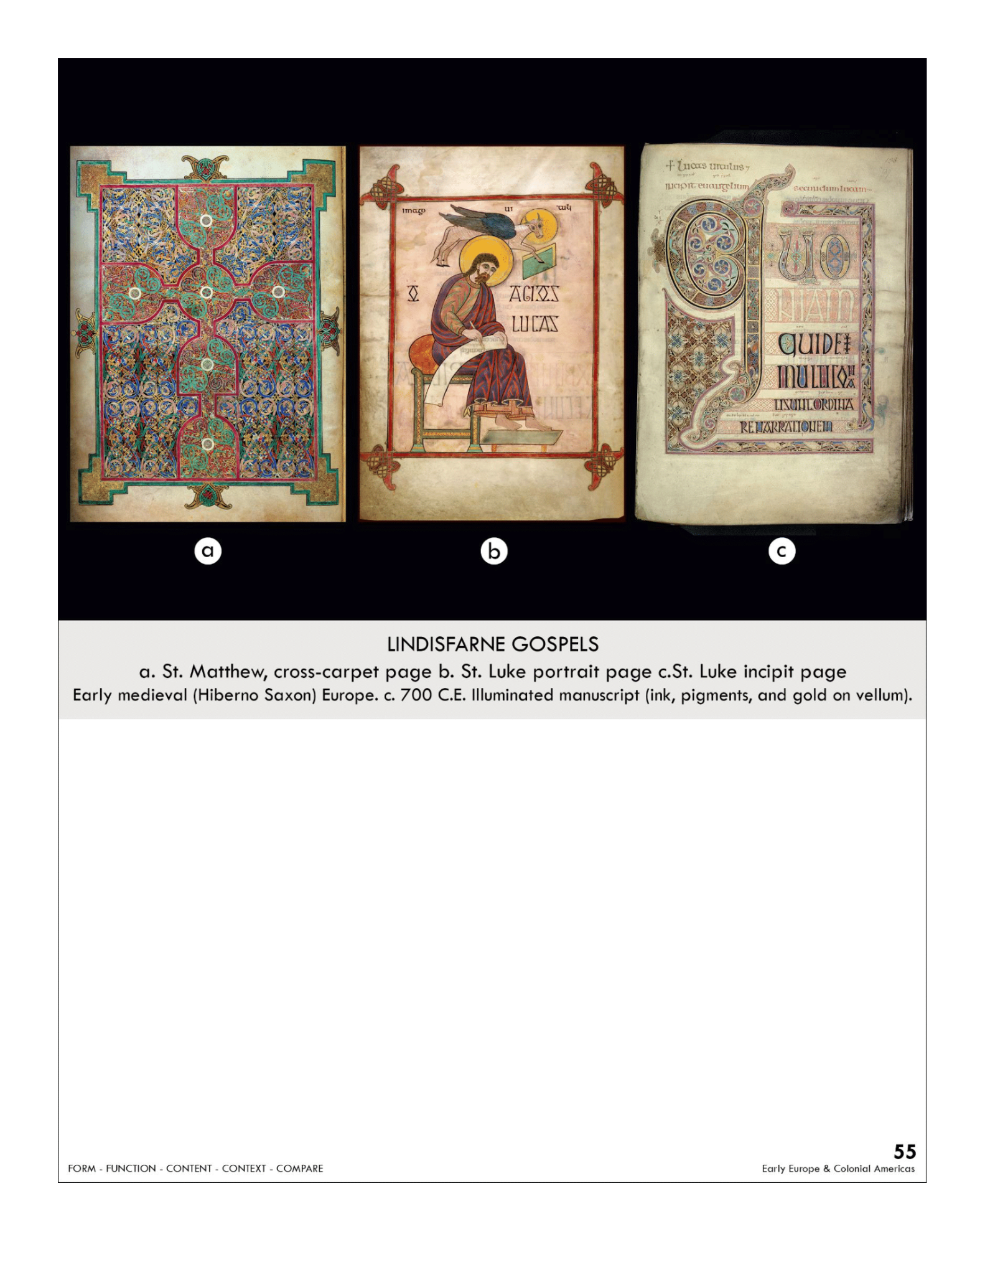

| **Form:** Vellum, animal skin, inks, temperament paints. Very well preserved, **a)** Designed and recorded with the use of ink pigments and gold vellum **B)**Intricate designs made with different colored pigments, Shapes create words **C)**Written and recorded with the use of ink pigments Tiny red dots that envelop words, Gold vellum  **Function:** Bible illustrated text of the 4 Evangelists. **a)**over and opening of St. Matthew’s Gospel **B)**Luke’s portrait  **C)**Opening of Luke’s Gospel  **Content:** Cover from 19th century, beautifully and commissary illustrated. **A;** Marriage between Chistain imagery and the animal-and-interlace style of the norther warlords line prediction, see a centrally located cross with Celtic knots, has horror vacuole very small, traces of animals, birds in the knots **B:**icon is the one and the **bull**, the icon is holding the book( angelic host is handing book/speaking into the ear of who is writing it. Example of knotwork and a little of the classical period. Curly-haired bearded evangelist sits on a red-cushioned stool, Wears a purple robe streaked with red, Gold halo = divinity, Above halo––flies a blue-winged calf = sacrifice on the cross **C:** In the gospel of Luke the first words translate to Quoniam Quedan- (because indeed) in Latin,  **themes: aminal life, siraked forms and swerling vertexes,** ,Example of **Insular** or **Hiberno-Saxon** art, Straightforward and not TOO stylizedA series of **repetitive knots** and spirals, Ribbons = contain abstract animal forms that twist. Birds  **Context:** Produced in the netherlandsFrom hospitals, illuminated by monks in the early dark ages. Most well preserved of all the gospels. Alluding to ancient Greece and Rome, ( the portraits) made by monks for their own use. Gospel: one of 4 books in the new testament. Mixing creative ideas from other cultures ( the Celtic and the Rome) there was much travel at the time. Manuscript; handwritten. Eadiaret =wrote the book. Made to honor God and St. Cuthbert. Lindisfarne = island off the coast of Northumberland in England, Produced in the British Isles between 500-900 CE, Time of social upheaval and devastation invasions, Made in Italy.  **Compare:** Islamic carpet, Merovingian looped fibulae (knotwork and abstract designs), Golden Haggadah  **55**  Early Europe & Colonial America |
| --- |

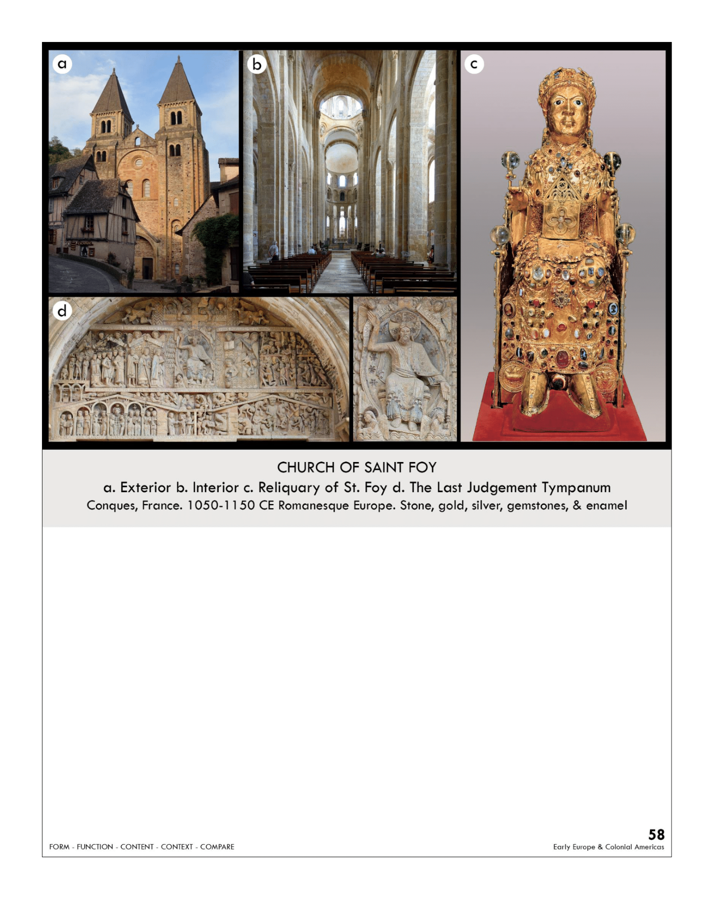

| **Form:** Church(exerior)/interior: Romanesque pilgrimage church, Cruciform plan, Cross commemorates Christ's sacrifice, Pilgrims traveled around the ambulatory and radiating chapels, paying homage to saints' shrines. It has a 69’ tall nave suspending a stone room=. Held up with repeating bays of arches, supported by carved pillars. The facade has two west work towers and a central towner over the transept/nave crossing. The apse is ringed with an ambulatory and radiating chapels, massive Buttresses on the outside provide support to the vault.  Reliquary: consists of jewelry, from pilgrims. Hammered gold, hollow death mask. Wooden interior covered in gold, silver gilt, and jewels, 33.5 inches tall (just over 3 feet tall), Contains Sainte Foy's remains, Uses spolia  **Function:** A Christian pilgrimage church, To host pilgrims on their journey to Santiago de Compostela in Spain, To bless its visitors, demonstrate their piety, and help them be saved on Judgment day.  Reliquary: To commemorate Sainte Foy as a Christian martyr and saint, To inspire veneration and increased faith in Christianity, To draw pilgrims (and now tourists) to the small town of Conques in Southern France  **Content:**  Church: Barrel-vaulted nave, with arches on the interior, nave, apse, 1 side aisle on each side, 5 radiating chapels surround the apse (in a semicircle), Prominent transept (cruciform church), Elaborately carved Tympanum on the South Portal of Christ and the Last Judgment. Contains relics of St. Foy in an elaborate gold reliquary  The last judgment: -Semi-circular relief carving above the doors to the central portal -Christ sits enthroned at the center (His right-hand gestures towards heaven, His left-hand gestures down, towards hell, On Christ's right: Mary, Peter, Christ's Right: an arcade covered by a pediment, symbolizing the House of Paradise, Abraham is seated at the center of the House of Paradise), pediment's opposite sider, under Christ's feet, angels open and release souls from their graves to be weighed/judged by God to determine if they're going to heaven or to hell. Pediment of the Lower register of Hell. from the book of revelations. ( entering through Hell leaves through heaven. Was painted. Reliquary: stolen from another french church. A disproportionately large head, repurposed from an ancient Roman statue of a child, The remains of Sainte Foy lie inside, hidden to the eye, jewels from pilgrims, gold leaf and silver glit over a wood core. Has an oversized head -represent a helmet. And a crown  **Context:** Church: Named after st. faith, pilgrims went to receive a blessing; their visitation = demonstration of piety, Located in Conques, France = on the pilgrimage route to Santiago de Compostela in Northern Spain( road of st. James), church was an abbey: it was part of a monastery where monks lived, prayed, and worked...not all of the original remains. A church had stood on the spot since the 600s, the Romanesque period 1050-1130. 9th century, Reliquary: Sainte Foy, a 12-year-old French, Christian convert lived in Southern France under the Roman Empire in 200 CE— Killed at age 12 for refusing to worship pagan gods --> seen as a martyr, Occasionally visiting pilgrims donated gems to be added to the reliquary as symbols of their piety/faith, brought the reliquary for profit. Reliquaries and relics became the most popular in the 11th and 12th centuries. The skull was stolen “holy theft”  **Compare:**  **58**  Early Europe & Colonial America |
| --- |

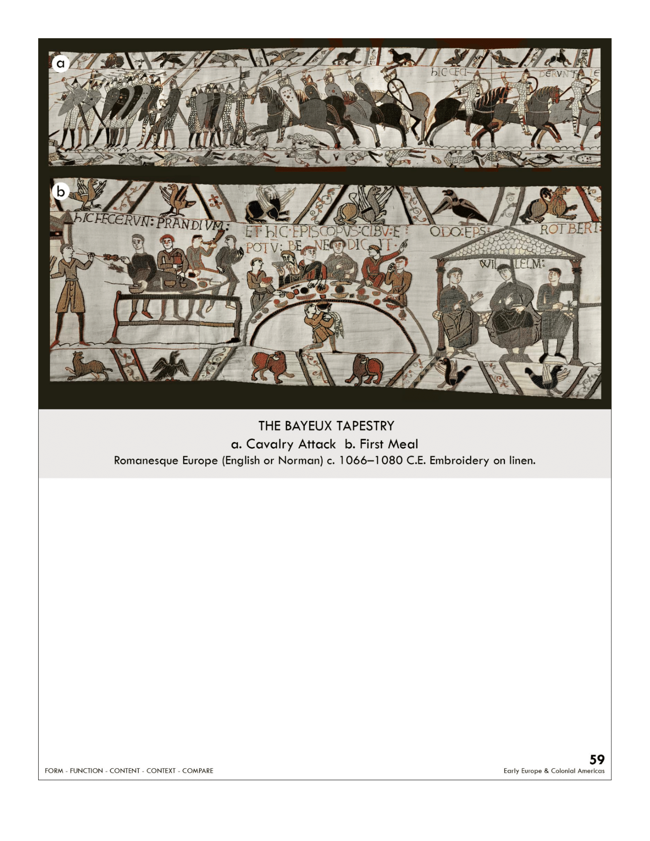

| **Form:** 230ft long 75 scenes over 600 people. imagery and inscriptions embroidered using wool yarn sewed onto linen cloth, high quality of the needlework suggests that Anglo-Saxon embroiderers.  -"A continuous narrative presents multiple scenes of a narrative within a single frame and draws from manuscript traditions such as the scroll form"  unrealistic figures, 1 dimensional, flat, no depth or space perception, split into 3 sections (thin top and bottom and larger middle section) in an attempt to show depth/foreground and background, top and bottom also function as boarders  It is embroidered work and not a true tamistary (woven)-made of wool on linen  **Function:** Historical document ( record the history of political conquest-not really religious). to commemorate the win of the Normans, give an accurate depiction of war.  **Content:**  Gigantic long scroll telling a story. Tapestry, but technically needlework. Scenes from history and other scenes from fables. 75 scenes w/ Latin inscriptions. Related to a Romanesque illuminated manuscript , contains animals, rel and imaginary like in contemporaneous books. Latin text. Frieze like pictorial narratives.  **Context:** Most famous work of english romanesque art - medieval art. Put it around the bayou cathedral for easter. Shows the Battle of Hastings( The Normans) -the normans defeating the Anglo Saxons at Hastings- England under norman control. in 1066- but begins with events leading up to it, Shows the of England between William, the Duke of Normandy, and Harold, the Earl of Wessex (in the end, William the Conqueror, or the Duke of Normandy won and became the first Norman King of England )  textile is missing its end which most likely showed William as king -Bayeux Tapestry created in Canterbury 1070  made within a generation of the war, believe the patron was Odo, Bishop of Bayeux, William's half-brother  scenes believed to have been adapted from images in manuscripts illuminated at Canterbury. Romanesque Europe.  **Compare:** Column of Trajan, *Night Attack on the Sanjô Palace*  **59**  Early Europe & Colonial America |
| --- |

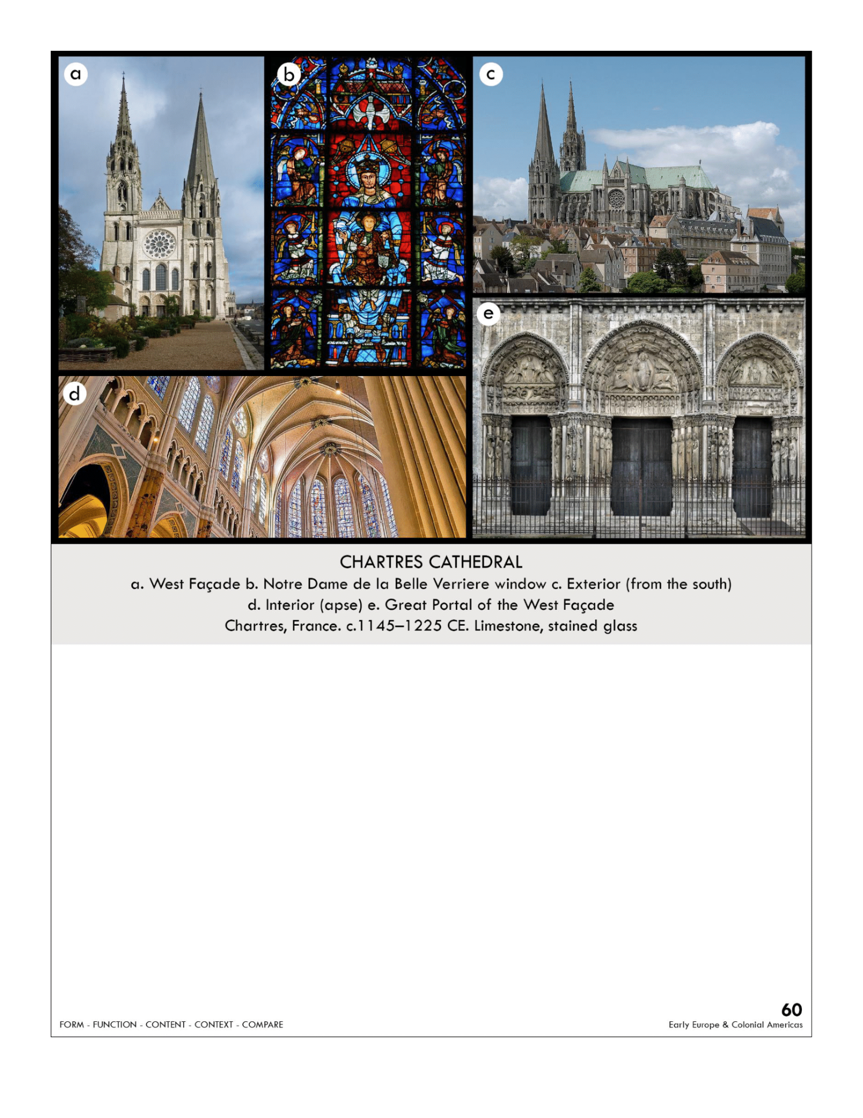

| **Form:** limestone and stained glass. West Facade **a)**: each figure is attached to a column. Made out of limestone. Interior is based on the basilica plan, the church is crossed by the transept creating a cross. Aisles on the side to assist pilgrims. There are three segments of the. E. the portal was made in the early gothic. Proportanaly beautiful, has rose windows from the west entrance. Has ribbed vault, flying buttresses, and pointed arches. *Nostradam de chartres*  **Function:** West Facade(a): Historians argue what the jamb sculptures represent( old(traditional view) or new testament). A cristain church , church dedicated to mary (Holds marys tunic worn at jesuses birth)  **Content:** Church**:**latin cross with 3 aisles, high nave supported by double flying buttresses.Left spire is late Gothic and more elaborate. Enlarged Chevet accommodated Church ceremonies. Tall vertical nature of interior pulls viewer's eyes to ceiling. Dark, mysterious interior, West Facade(a): main tempitum showing Christ surrounded by Avandulests . The Jamb sculptures are elongated and stylized figures. The faces have serine naturalism. Stylized dramary for decoration. Feet are floating on the pillars( made it more of the imagination) they have little mass and focus on the straight line. North royal portal: shows Jesus before he is alive- right is after he's alive, and the middle is his 2nd coming. Stained glass shows scenes of various kings and queens; the main piece shows Mary as the queen of heaven with Jesus on her lap. ( throne of wisdom) more worldly, enviding . The window uses plate tracery. South transept portal statues : shows realism and naturalism that is unlike other sculpture of the cathedral and era. Compare D:  **Context:** West Facade(a): there was a fire in 1194 that required rebuilding= accept this, the cathedral held the relic of the virgin mary’s tunic : that she wore giving birth to Jesus. West: early gothic, the rest is high gothic. Becomes THE model for a gothic cathedral. One of the earliest of the traditional gothic cathedral plan, became the standard. Rose windows were gifts from queen castillo. Age of respecting women/chivalry more status this time then they ever have. Has a mixture of styles a little, Gothic style of painting/ sculpture/ people. Elongated, stylized/idealized figures.  **Compare:** Hagia sophia, doryphoros  **60**  Early Europe & Colonial America |
| --- |

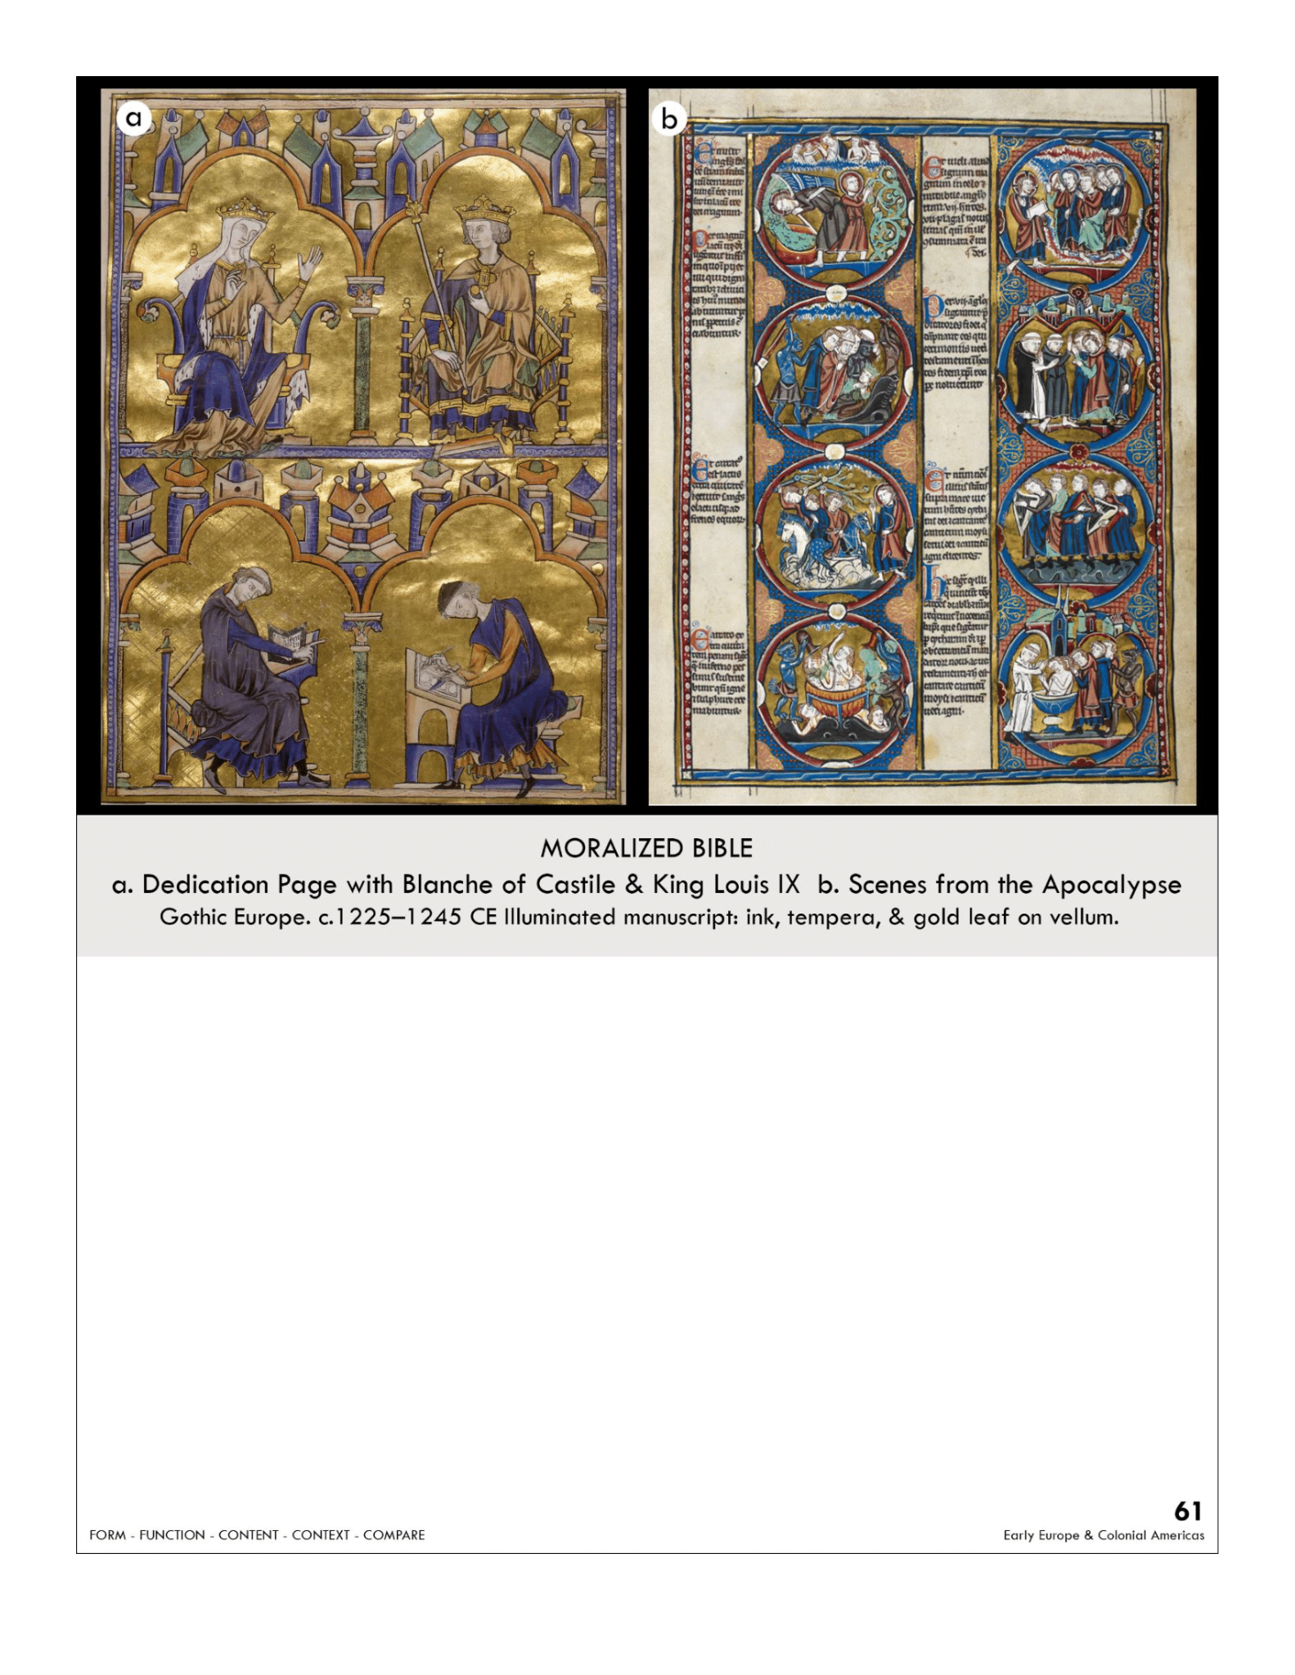

| **Form:**  Illumination, golf leaf, painting and drawing, heavily illustrated, medallions- common at the time.  **Function:**  Illustrated bible. ( graphic novel), personalized bibles. For personal ues of the french royal family  **Content:**  On the left scenes from the apocalypse- book of revelations-, has 8 medallions, have a morizized look, stained glass windows, bottom is a monk teaching a professional illuminator how to paint( church teaching people) above shows mother- banch or cassel teaching her son how to be king( louie the 9th). new/ different style, softer and more realistic then most byzantine influenced art at the time. Mevievel bible picture. Pairing the old and new testament . aa very uniform style from page to page  **Context:**  Illuminations made by provisional workshops. High gothic period. Made by professionals not in monasteries, anyone could buy, and cost about as much as a house. Many artists involved, none of them named. Commissioned by queen blanche of castile. Ruler at the time was king Louis IX. 13th century gothic period. dazzling and edifying, represents the cutting edge of lavishness in a society that embraced conspicuous consumption.shows the rising influence of secular queens. Shows a moment of teaching . done by several artists  **Compare:**  **61**  Early Europe & Colonial America |
| --- |

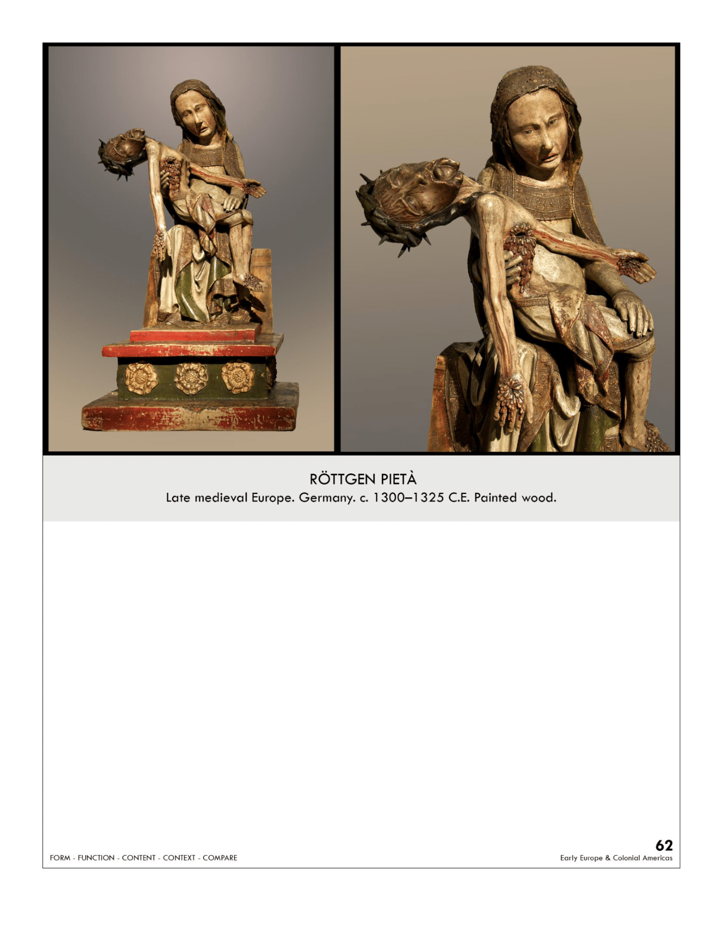

| **Form:** Wooden sculpture, painted, built on a small scale. Exaggerated naturalize, humanized, stylized. Body is twisting and contorting. Paint less vibrant then it one was and worm holes on marys head, most of these pieta status were found in germany at the time. The wood sculpture is unique.  **Function:** Privet statue for devotional use, chistianity, religious. To make you feel the event. Artistic viewing during prayer. The lamentation section of the stations of the Christ. Would have been on an alter with other art, common in german abbeys  **Content:** Abstract, blood spilling out of his sides. ( almost allude to looking like grapes) very dramatic, Spirituality, mysticism, pure emotion. Shows the mother of god holding her dead son on her lap. Chists had a sharp crown of thorns and a lot of blood flowing/exploding out of him(3D wounds) that shows a making it violent and gruesome scene. Mary shows anger and confusion in her face, empathizes marys humanity she is draped in the typical garb with heavy fabric and she still looks young, but she is suffering, traces of color, red of blood and green of the drapery. miserable . Jesus after the crucifixion= Extremely skinny, ribs visible, body is contorted.  **Context:** Late Gothic period, very humanized version. Early 14th century. The are is changing( mary not being depicted as so divine) scraping away the narrative elements and showing a more emotional image. Unlike the art of the high and early gothic where there was little emotion and personalization. German sculpture= often made of wood  -this new depiction and way of Christian thought was called “the patient Christ”  **Compare:** Giotto Madonna and child  **62**  Early Europe & Colonial America |
| --- |

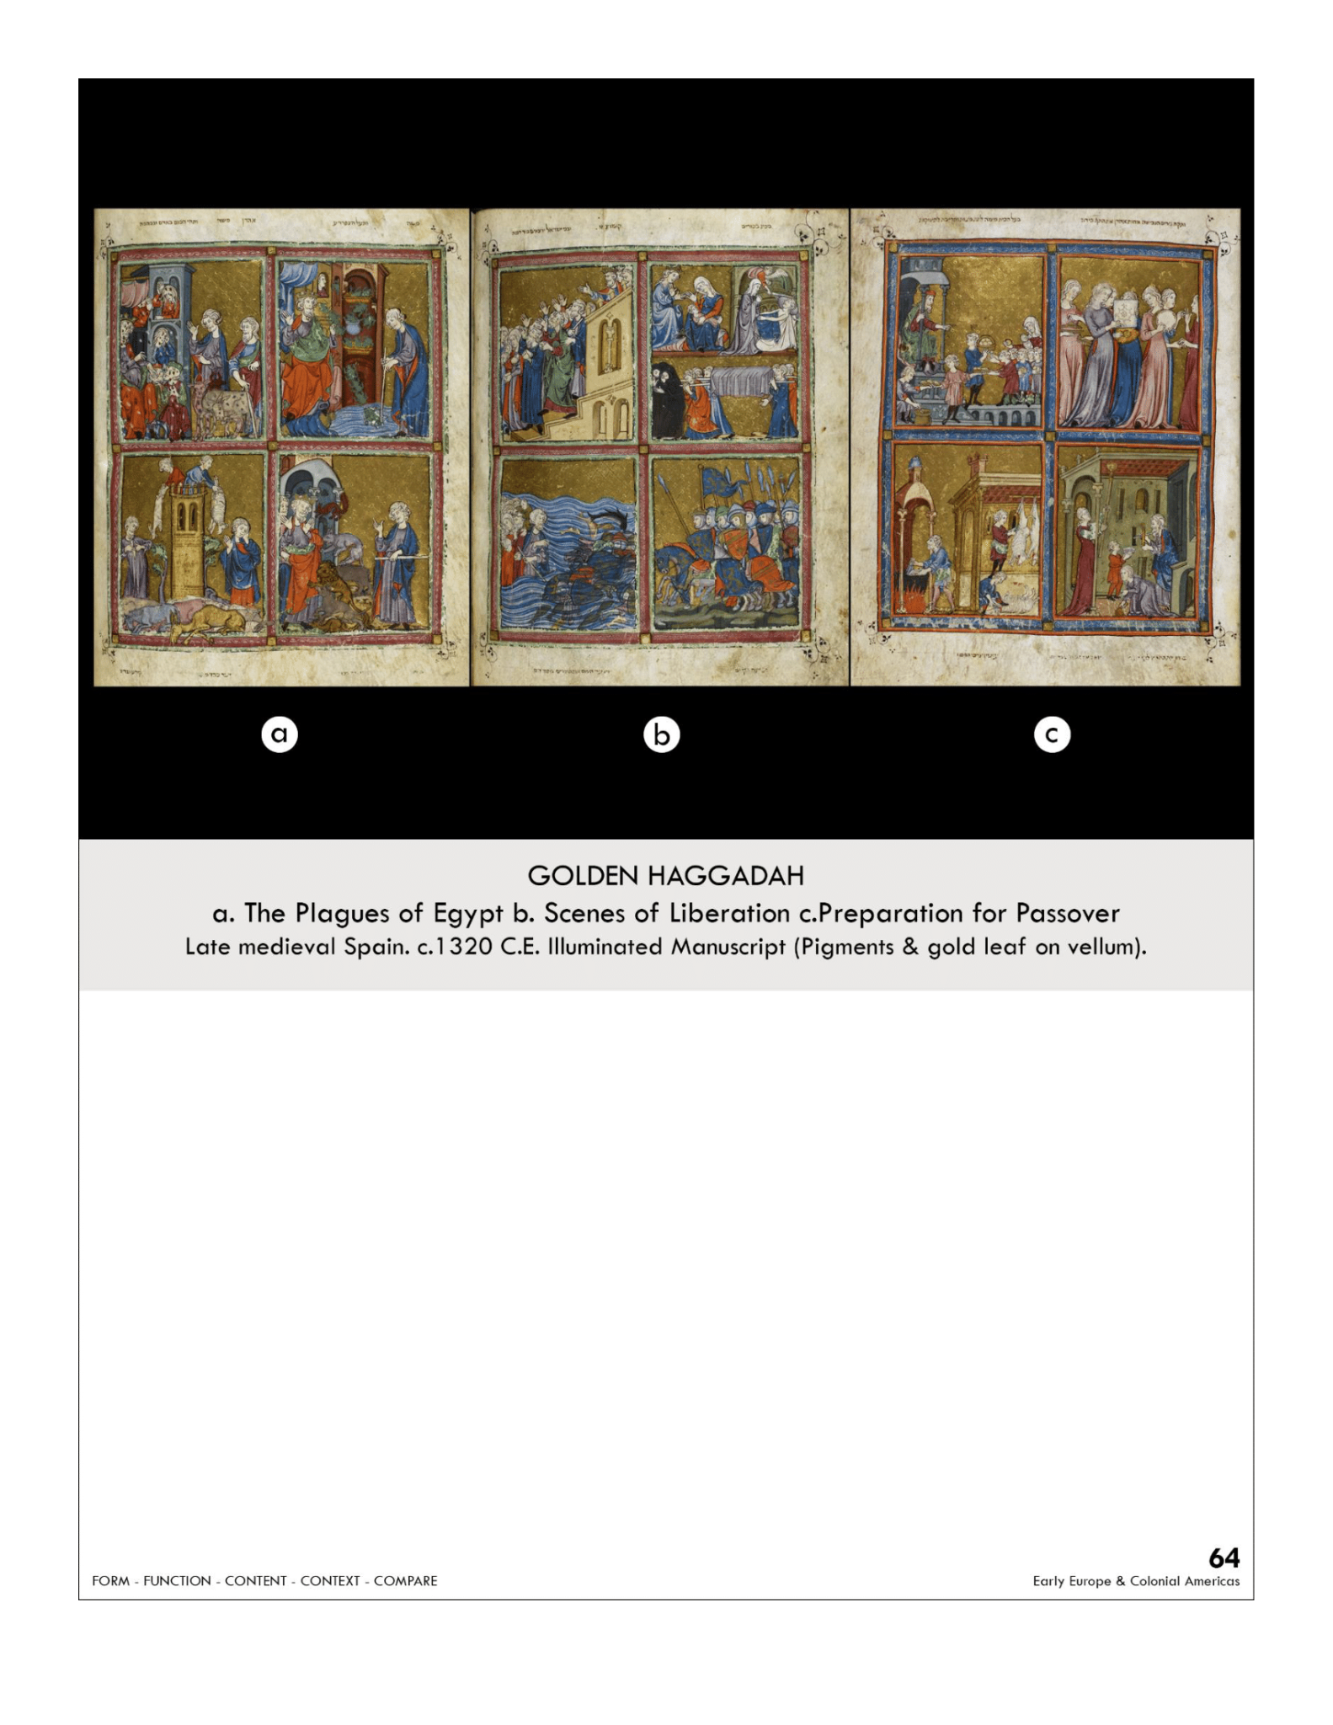

| **Form:** Illuminated, golf leaf of vellum , drawing, golden leaf background, animal skin pages, 56 miniatures. Painted in barcelona. resemble s christain gothic ( long flowing bodies, small architectural details) 56 miniatures.  **Function:** Illustrated version of the a haggadah, aid to the sader, celebrated during passover ( depict the story of passover) used at home/personal. Shows the wealth of the owner, stands as a testament of the impacts/significance of jewish culture in spain.  **Content:** The 1st page shows God bringing the plagues onto the people, 2nd when Moses leads people across the Red Sea, scenes of the liberation. ( all events from the book of genesis and exodus), shows the story of passover. - salvation for slavery ( told at seder)  **Context:** Manuscripts for the local jewish population. Story of exodus, 2nd book of the bible, story of Moses leading the people out of egypt. High Gothic period illumination. Haggadah literally mean: narration.  Late Romanesque / Gothic Period- o Art was often didactic  - Jewish Art - Jewish people often patronized work as the Christians and Muslims during this time, Jewish patrons would often use Christain painters to decorate important sacred books  - It was forbidden to create images at this time, Skeptical of who made is, thought to might have been a Christain, It was justified by being didactic  **Compare:**  **64**  Early Europe & Colonial America |
| --- |

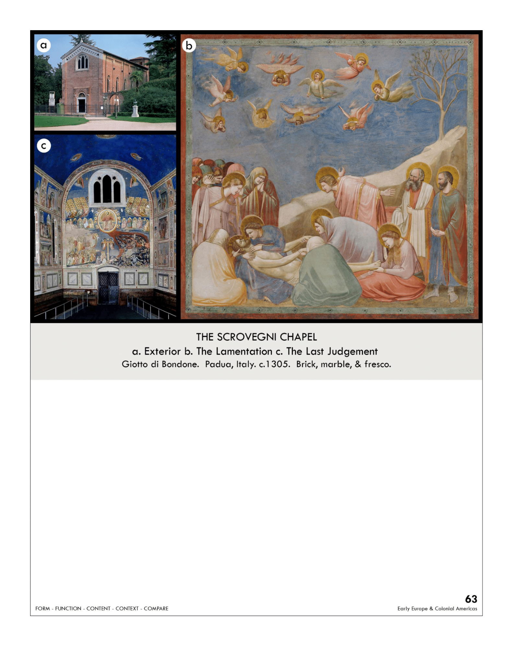

| **Form:** Brick chapel/ gothic. Fresco paintings. Plaster and then colors in pigment and water painted onto the plaster, paintings show real emotions and shows stories (new in art). New, dramatic art. Lapis Lazuli for the bright blues. Painting in buon fresco.( holds pigments better and must paint faster before if drys)  **Function:** a public chapel for the worship of god, the people of. Atone for the sin of usury, bankers =usurers  **Content:** Anotherknown name as the arena chape l, a gothic chapel with one wall of windows, the interior is entirely covered with paintings. Ceiling shows giottos version of heaven, deep blue, with saints the virgin mary and Jesus . Many paintings, alone the top are scenes of life of mary, bottom rows are scenes from the life of christ. The last Judgment: most gothic of all the work, gruesome, shos demons and devels. Christ in the middle, angles blowing trumpets. At the button there is the scavini is giving/dedicating this chapel to christ, and he puts himself among the faithful … shows figures from behind. There is much 3 dimensionality, shows personalities in his painting.  Lower left corner, depict christ who has just been brought down from the cross, shows realism and emotion, depicts total grif, intense and shows figures from behind, halos are unrealistic, 2D. Shows Jesus in death, feel the art and the story. Next to in is jonah and the whale  **Context:** built by bankers, knows as the scrivanies(the family) = was a sin to have rithurs so he donates a lot of money, no windows, only windows on one sid, possible made/designed by giotto, interior entirely painted by giotto in his workshop. Giotto humanized the art and makes them realistic, far away from the byzantine style, looks 3D and realistic, uses form and life. ( especially of marie's parents meeting in a bridge). Giotto was an absolute genius. Whole chapel was VERY expensive. Use of blue. Giotto the creator of the paintings had a workshop and used fresco and perfected techniques. Giotto worked in florence.  **Compare:** last judgment of st foy, Sistine Chapel  **63**  Early Europe & Colonial America |
| --- |